NAME:K.NAGA VENKATESWARAO
ROLLNUMBER:24B21A4616
TASK:GOOGLE DORKING

GOOGLE DORKING :
Google Dorking is a hacking technique.
it can uses advanced search operators on google to find hidden data, private files, and weak system settings on websites.
finding specific information that may not be easily visible through normal searches.
it is mainly useful in cyber security for OSINT(open-source Intelligence).
OSINT is the process of gathering and analyzing publicly available information for intelligence and security purposes.

OPERATORS IN GOOGLE DORKING:
BASIC OPERATORS COMMANDS:
1.site:
It can uses to searches a specific and particular site/domine.
It can shows a results how many sits/dominoes present the with in a site name shows a all lists.
EXAMPLE:site:example.com cybersecurity.
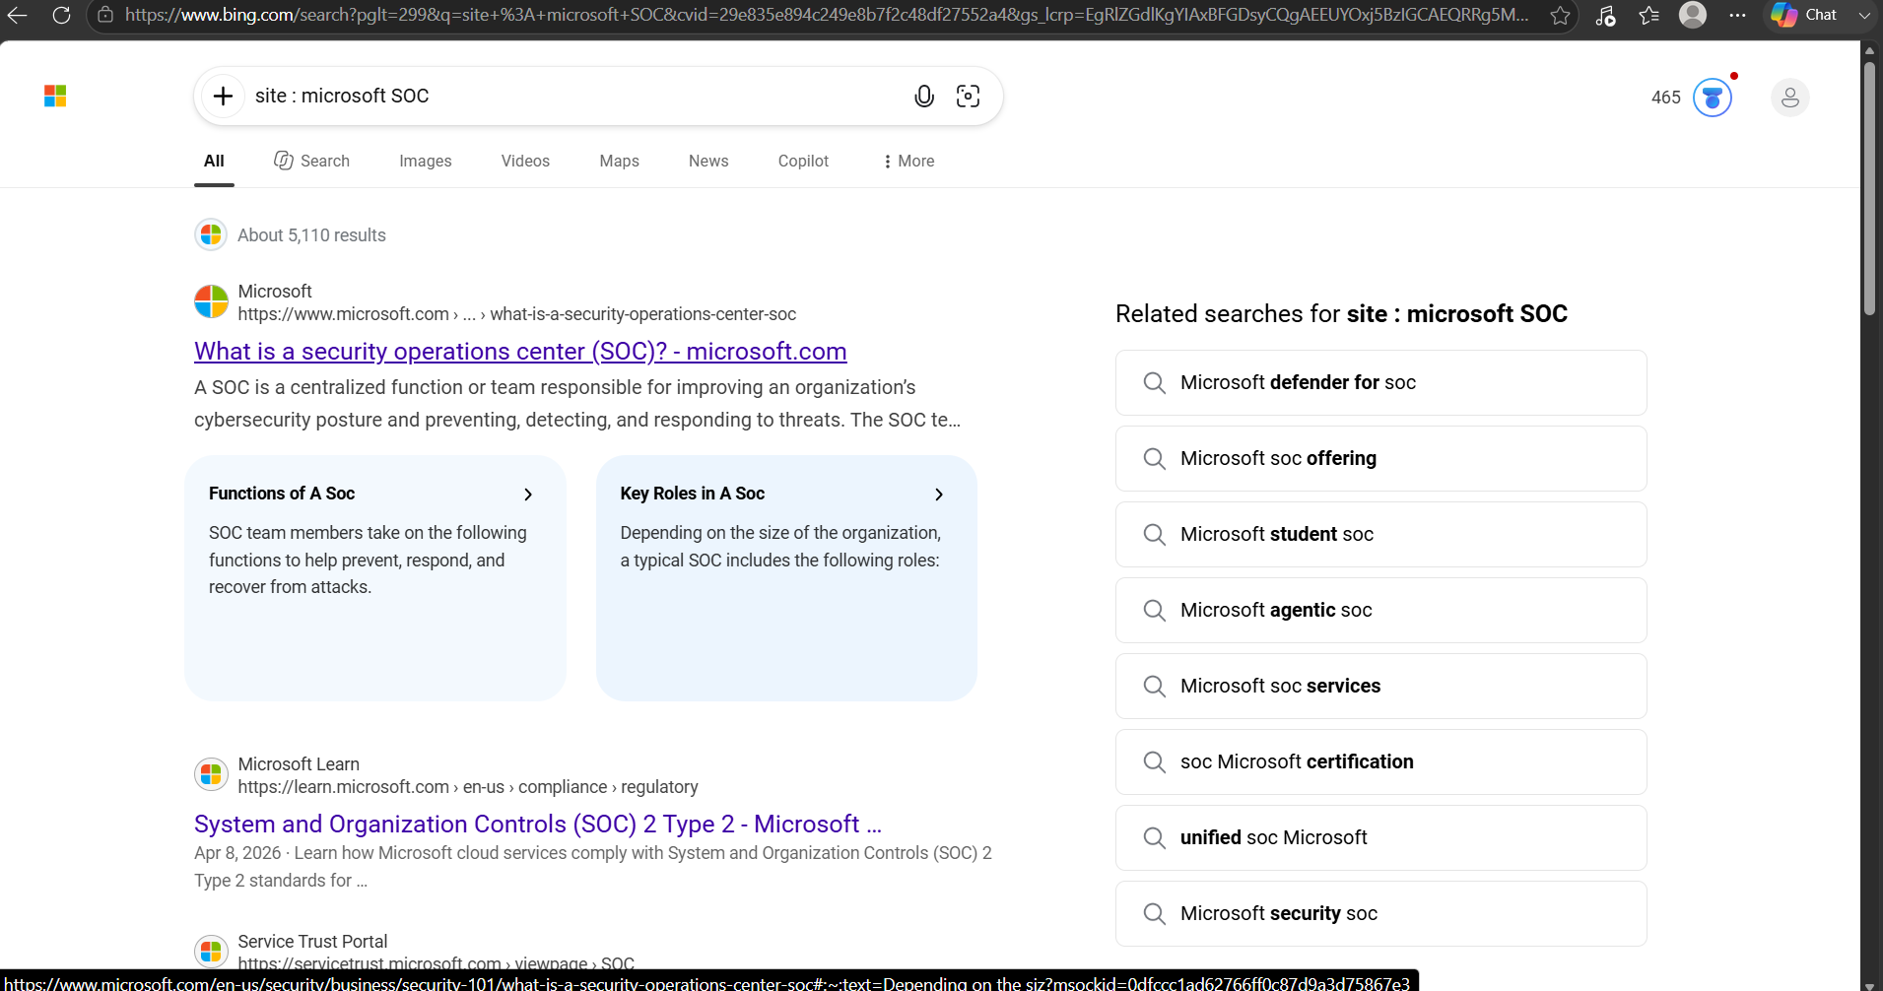
2.filetype:
It can uses to searches a particular filetype what we can mention in the query.
EXAMPLE:site:example.com filetype:pdf.
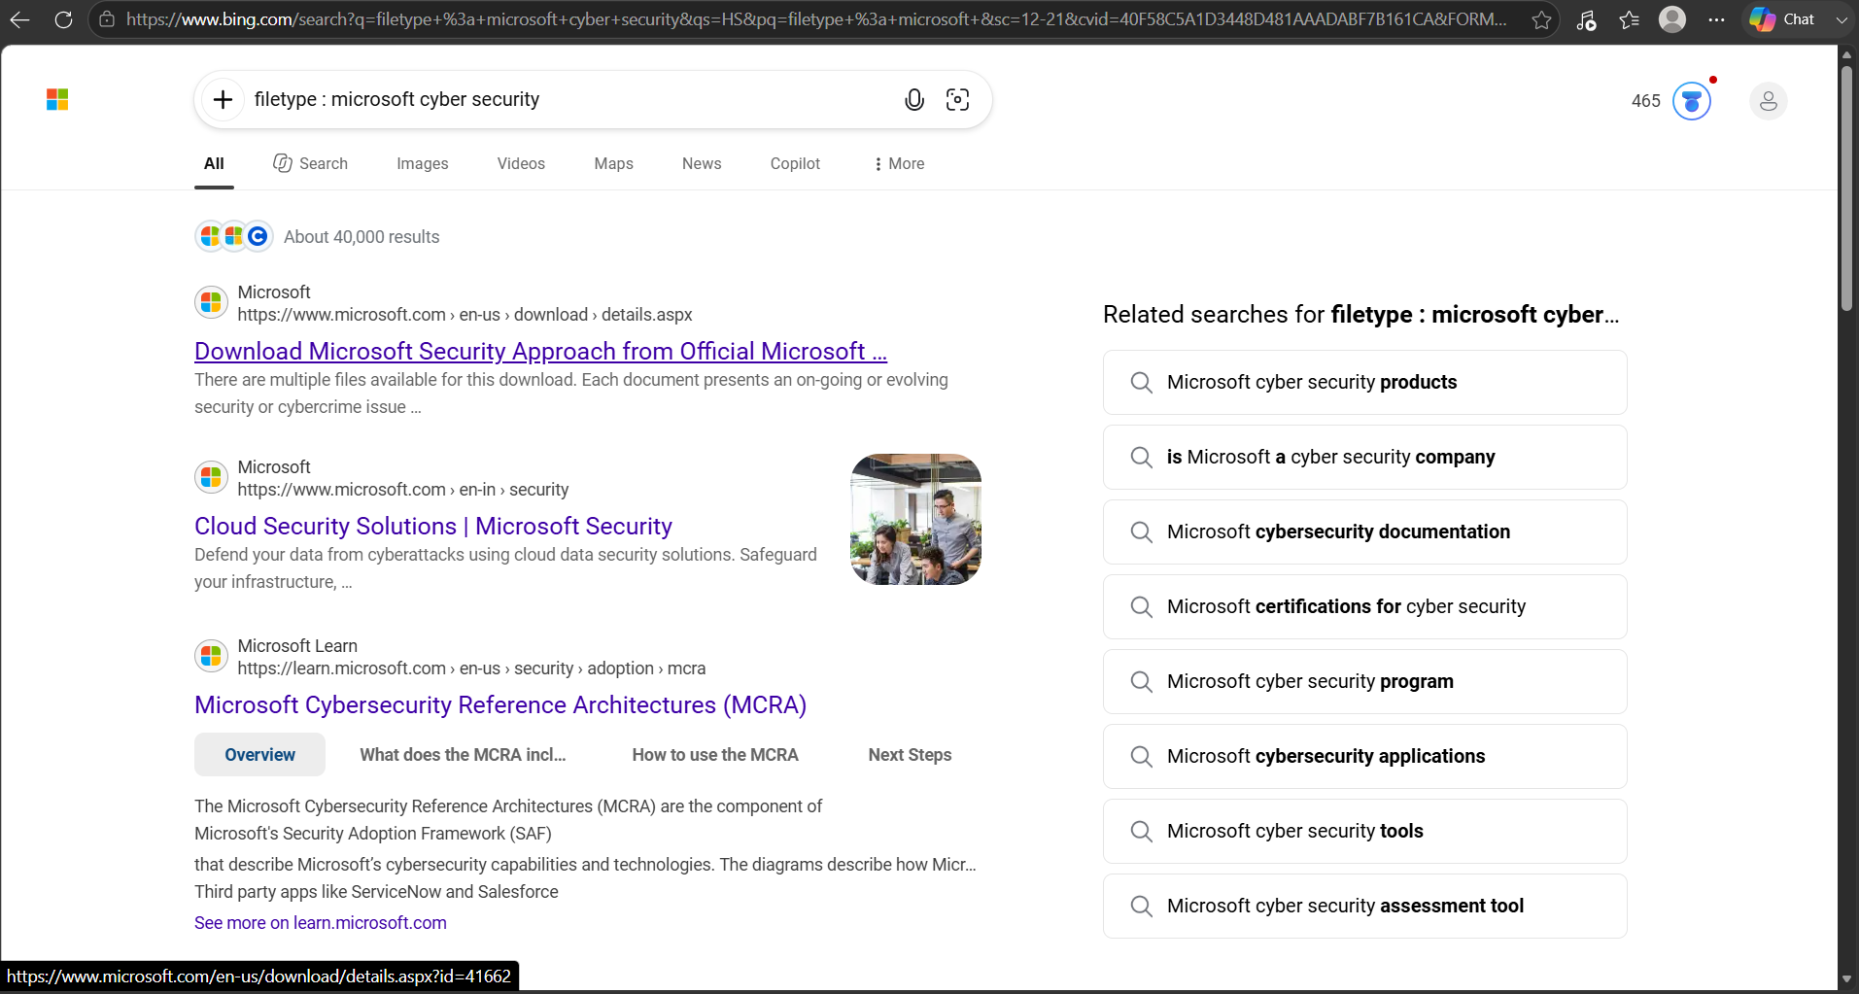
3.intitle:
It can uses to searches a specific word in the web page (title).
EXAMPLE:site:example.com intitle:security.
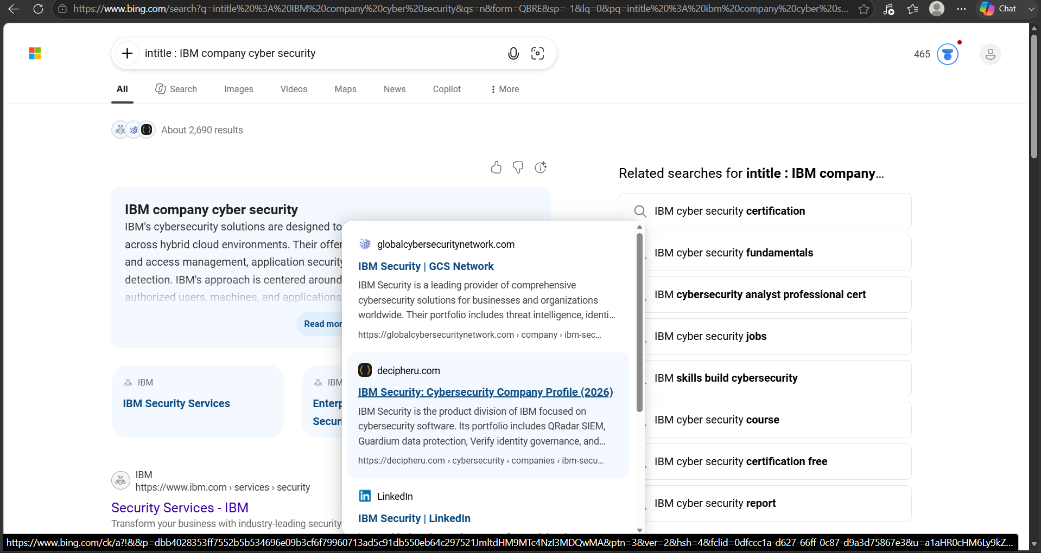
4.inurl:
It can uses to searches a URL matching one of the keywords.
EXAMPLE:site:example.com inurl:login.
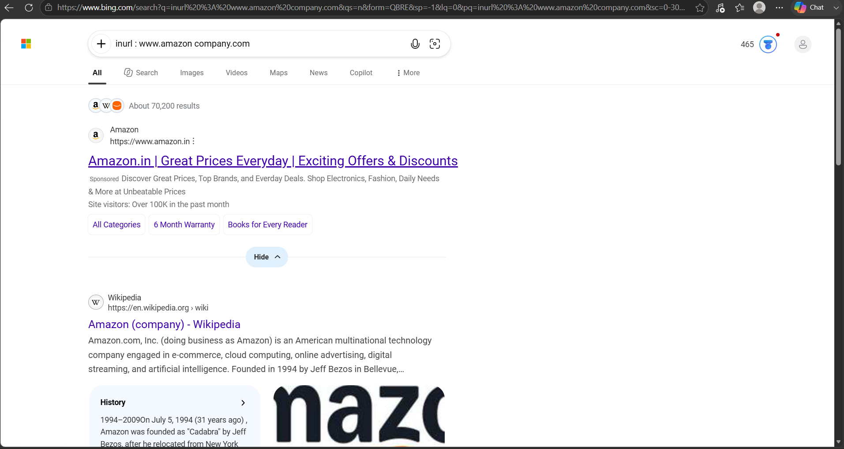
5.intext:
It can uses to searches a specific text within a webpages.
EXAMPLE:site:example.com intext:"cyber security".
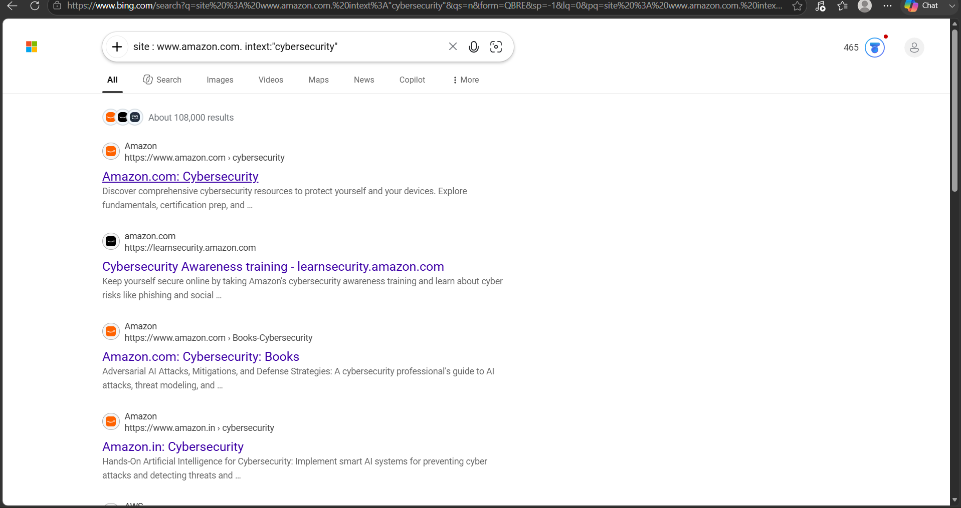
6.cache:
It can uses to shows the version of the webpage that google has in its cache. And also reveal sensitive information like passwords and usernames.
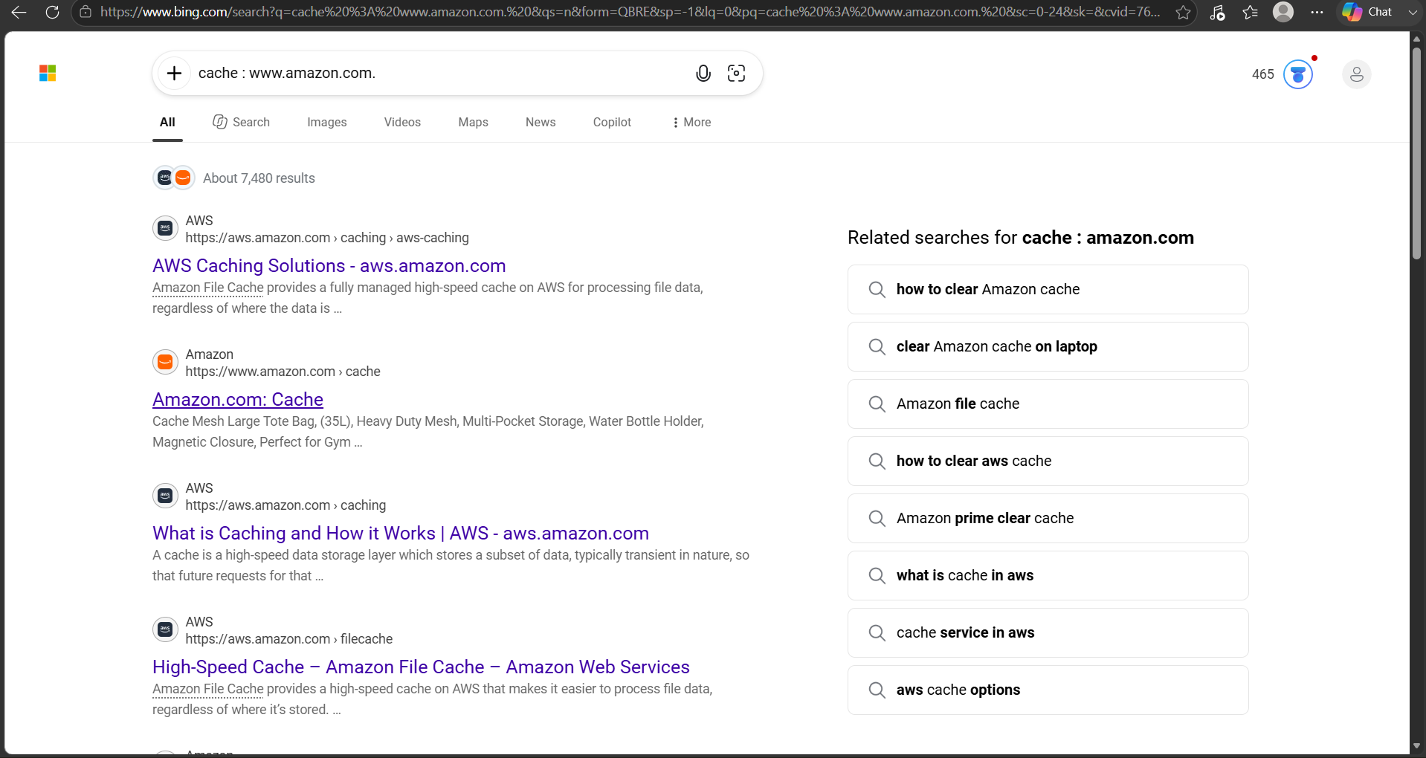

ADVANCED GOOGLE DORKING COMMANDS:
1.Exact phrase" ":
It can searches a specific word/text within a Quotations.
EAMPLE:"network security"
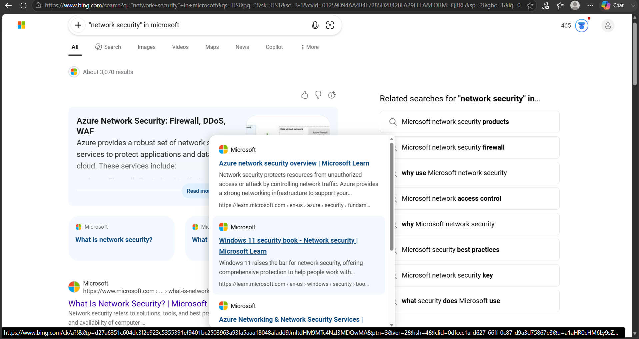
2.OR:
It can searches a words either of two terms.
EXAMPLE:site:example.com security OR cybersecurity.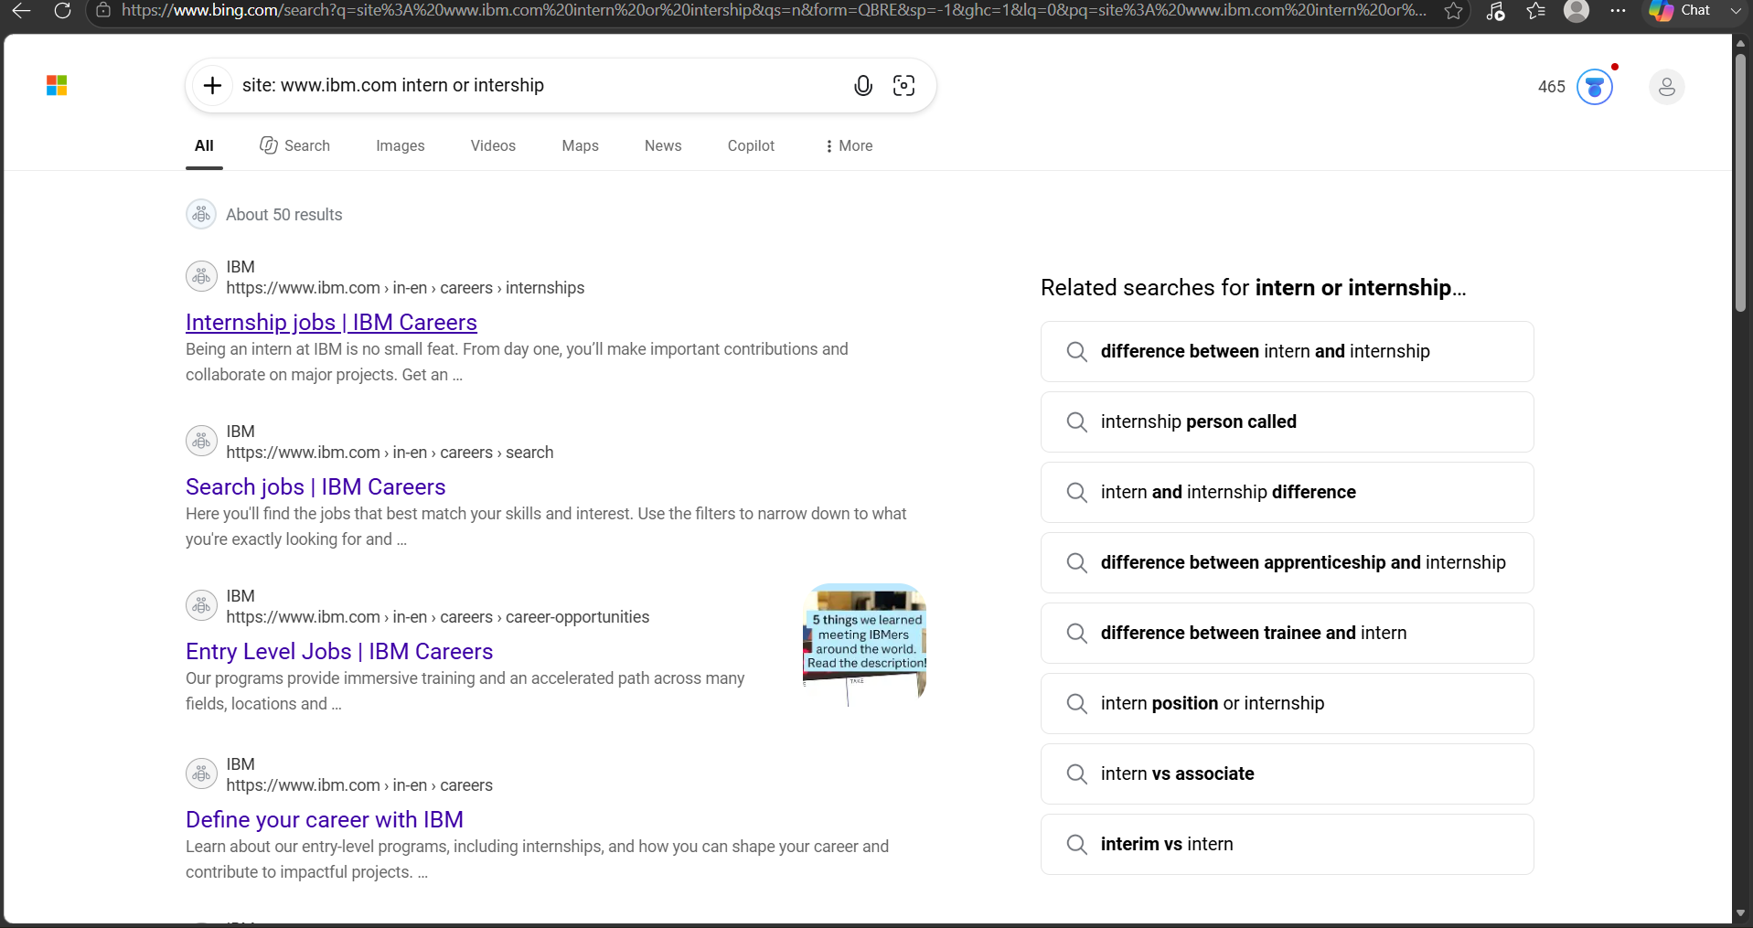

3.(-)Exclude a term:
This attempts to exclude pages containing.
EXAMPLE: site:example.com security -jobs.
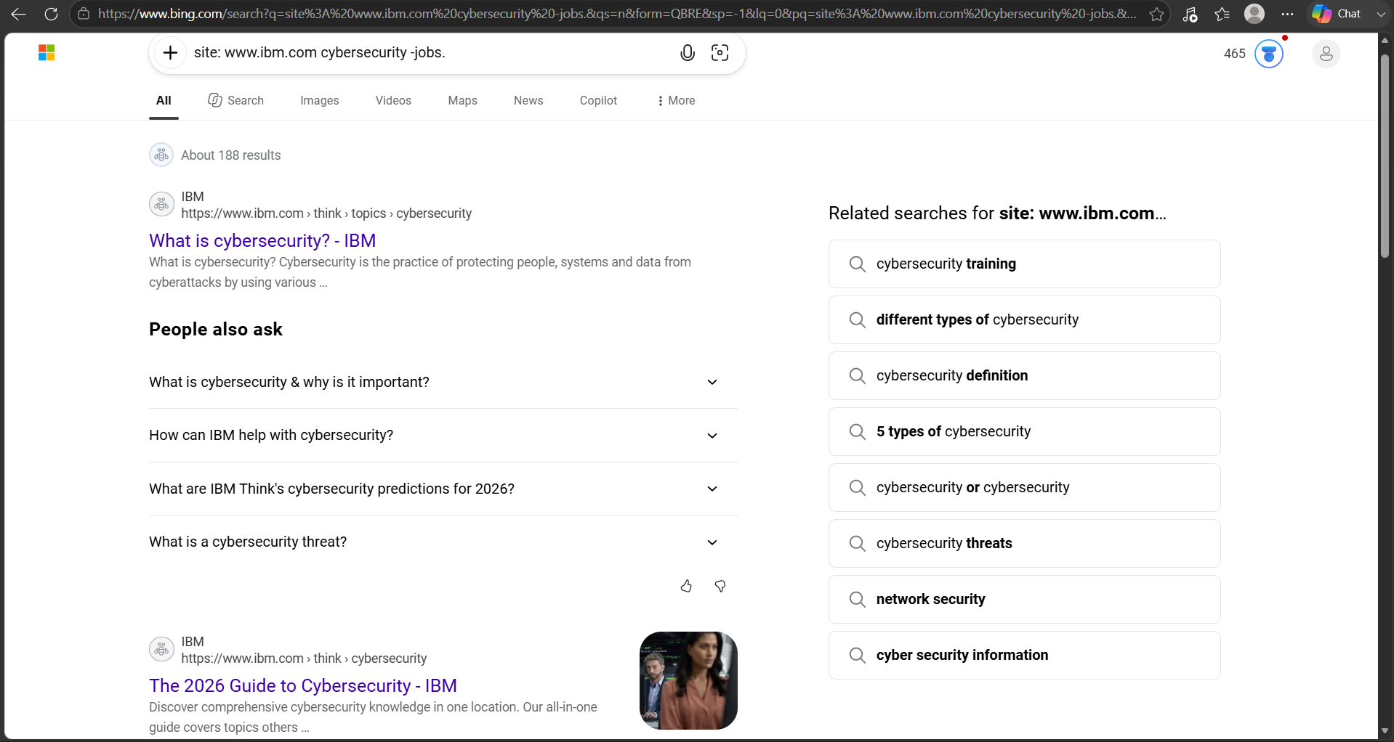
4.Define:
Returns definitions of a word or phrase.
EXAMPLE: Define: cyber security.
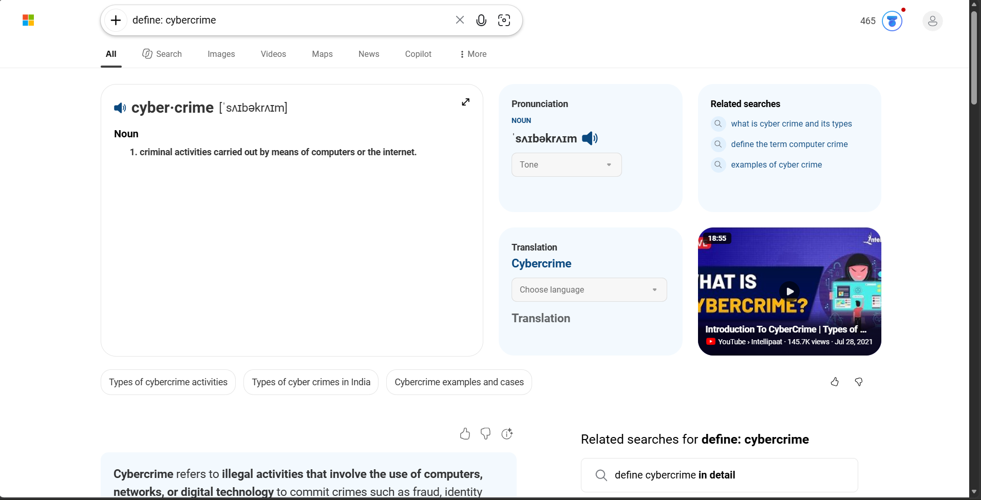
5.Link:
Finds a web pages linking to a specific domain.
EXAMPLE: link:www.example.net"kali purple".
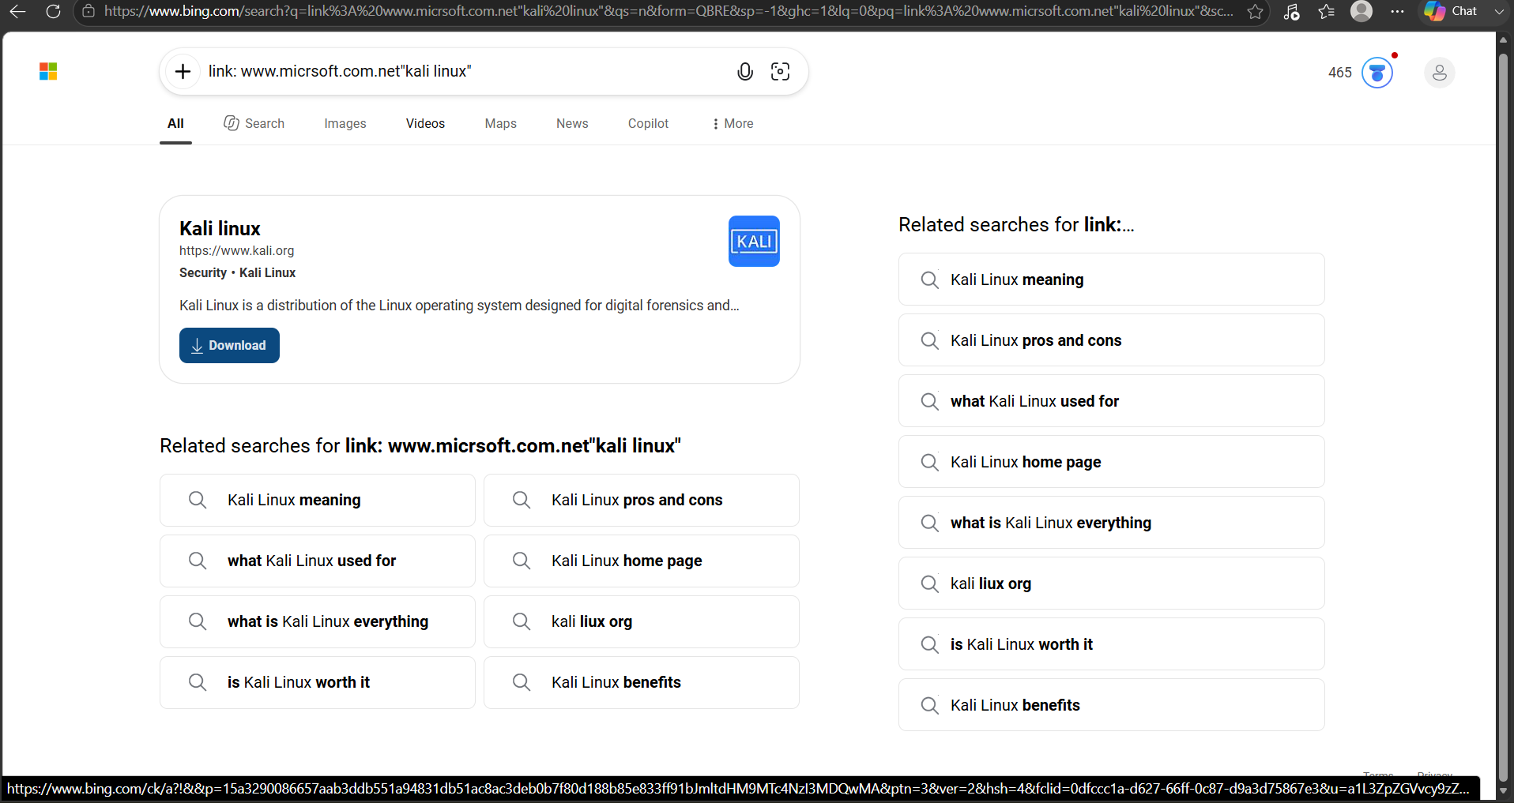
6.Map:
Returns a map of a specific location.
EXAMPLE: map: l Kakinada.
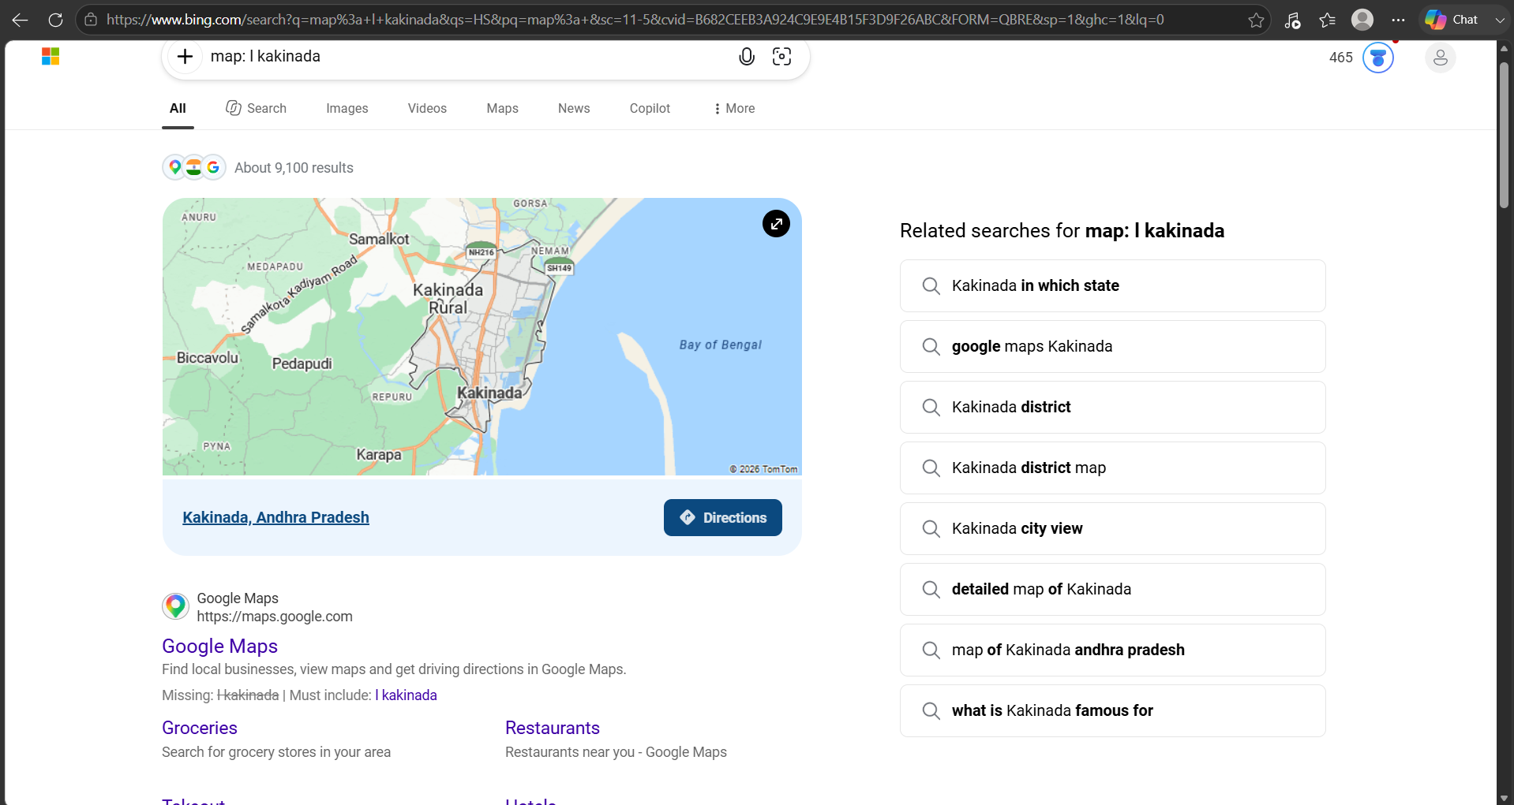
7.Phonebook:
Finds a specific phone numbers and contact information.
EXAMPLE: phonebook:7093183927.
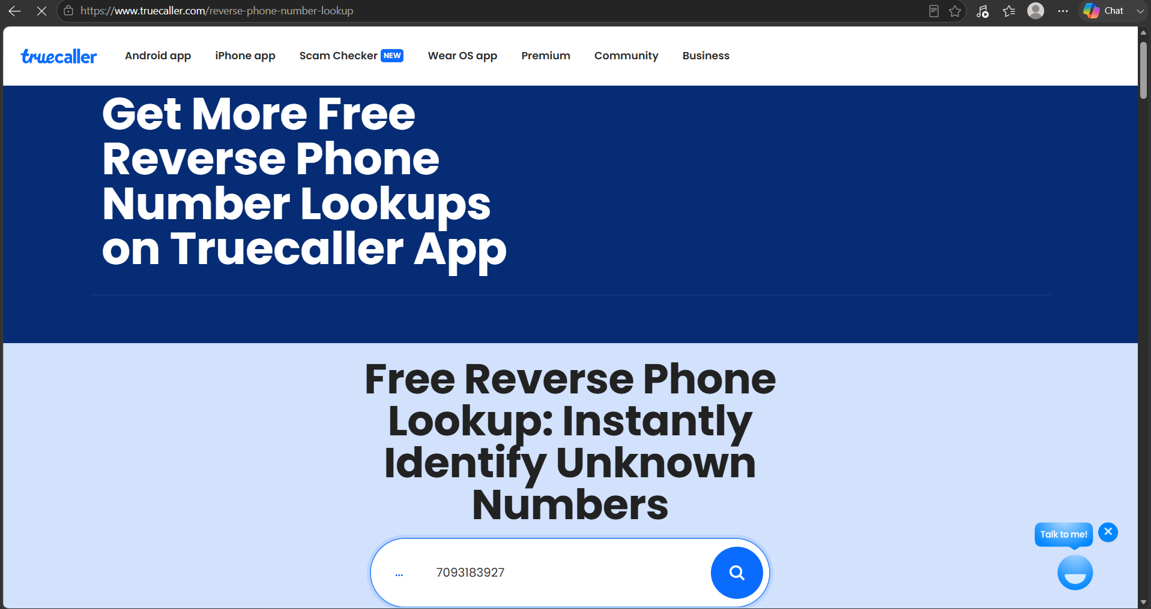
8.Related:
Returns websites related to a specific domain.
EXAMPLE: related:www.microsoft.security.
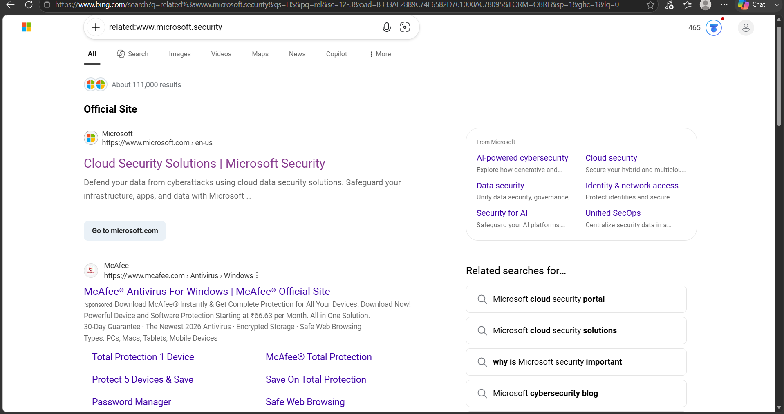
9.Ext:
Restricts the search to specific file extensions.
EXAMPLE: ext:php site:microsoft.com.
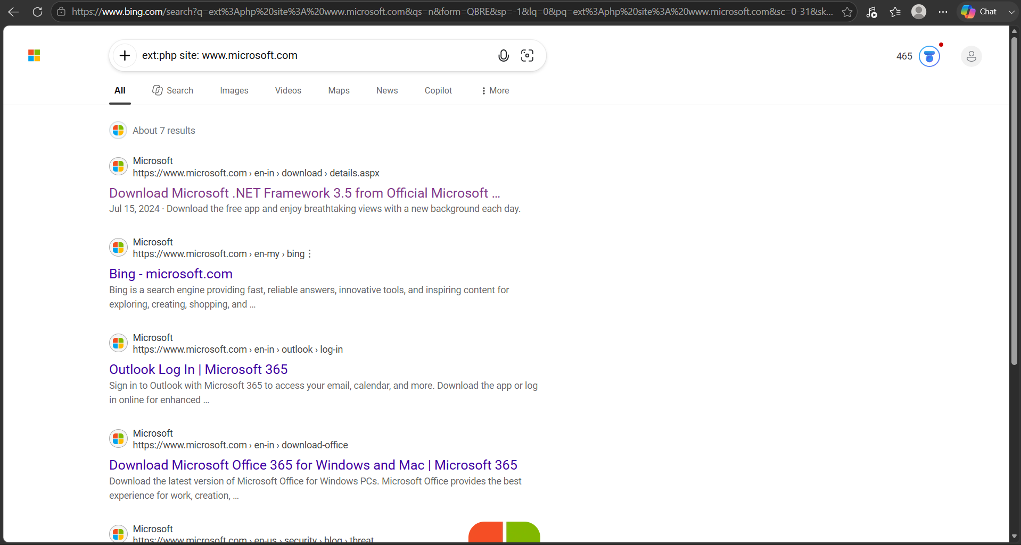
10.inanchor:
It can searches a specific text within a webpages anchor text.
EXAMPLE: inanchor: "cyber security".
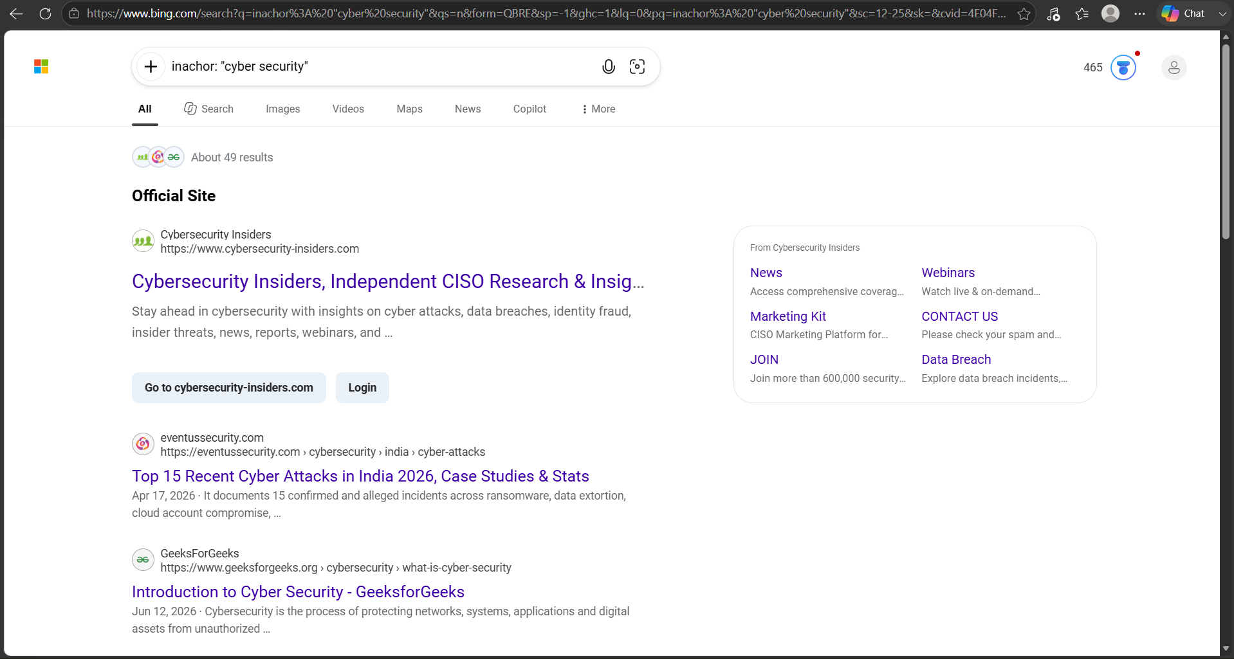
11.Wildcard:
searches for a specific text within a wildcard.
EXAMPLE: wildcard:"cybersecurity".
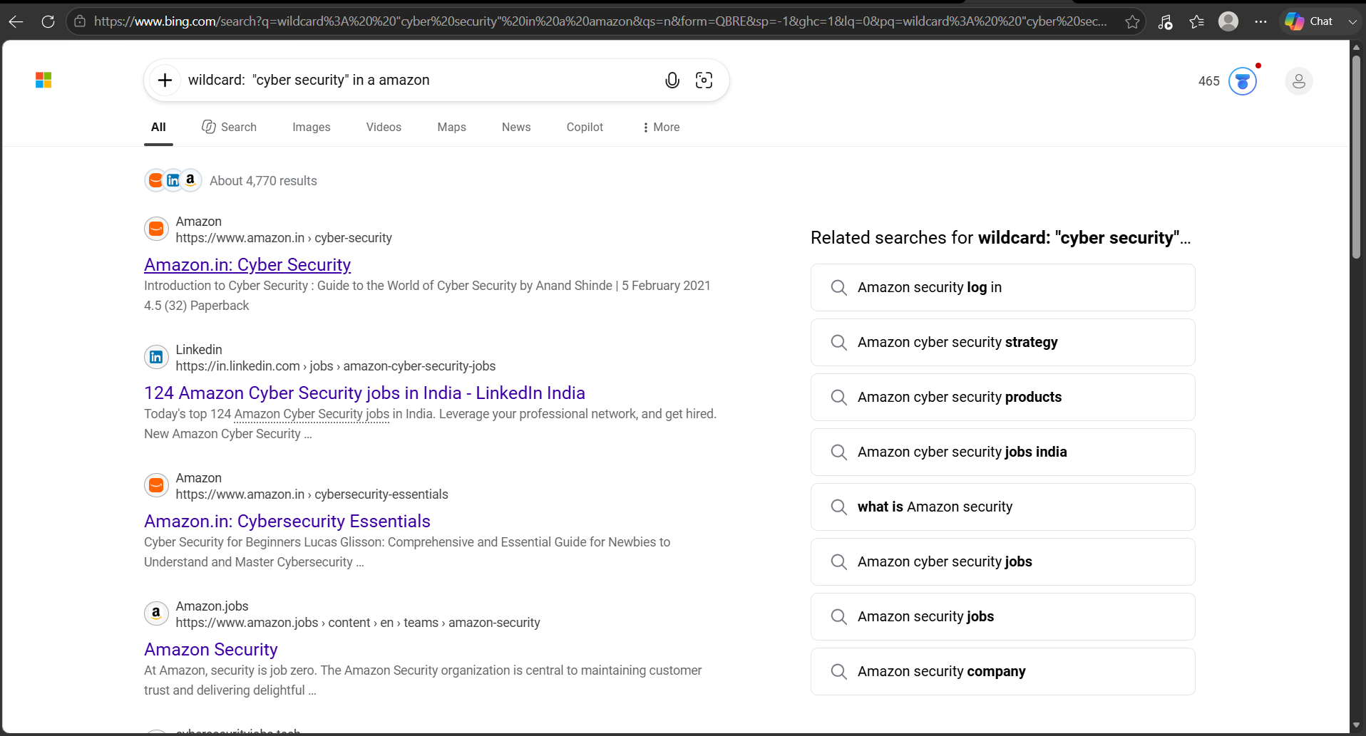
12.index of:
Searches for a specific files within a directory.
EXAMPLE:"index of""database.sql.zip".
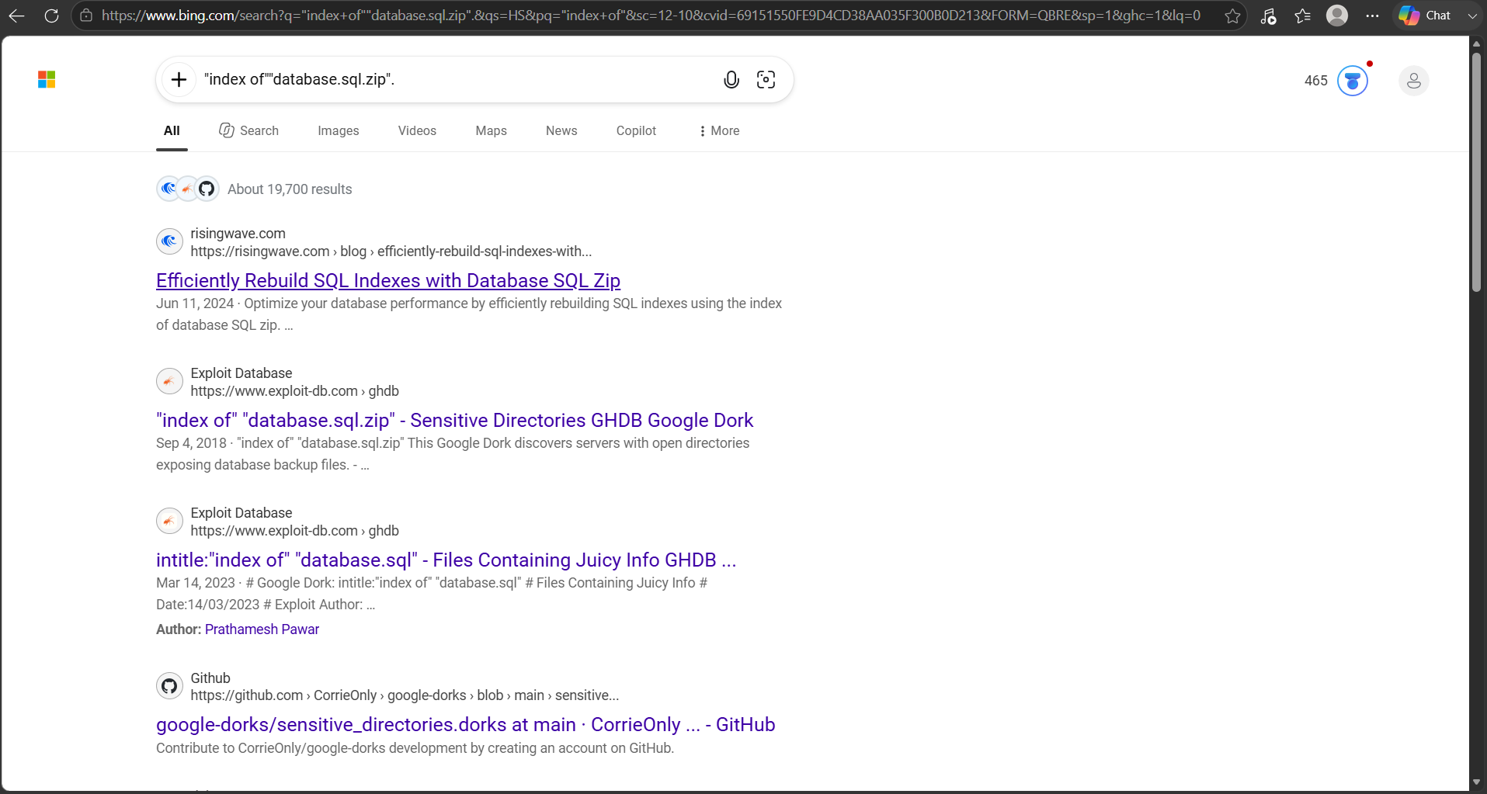
13.Zoom-bombing:
Searches for a zoom meeting URLs.
EXAMPLE: inurl:zoom.us/j and intext: scheduled for.
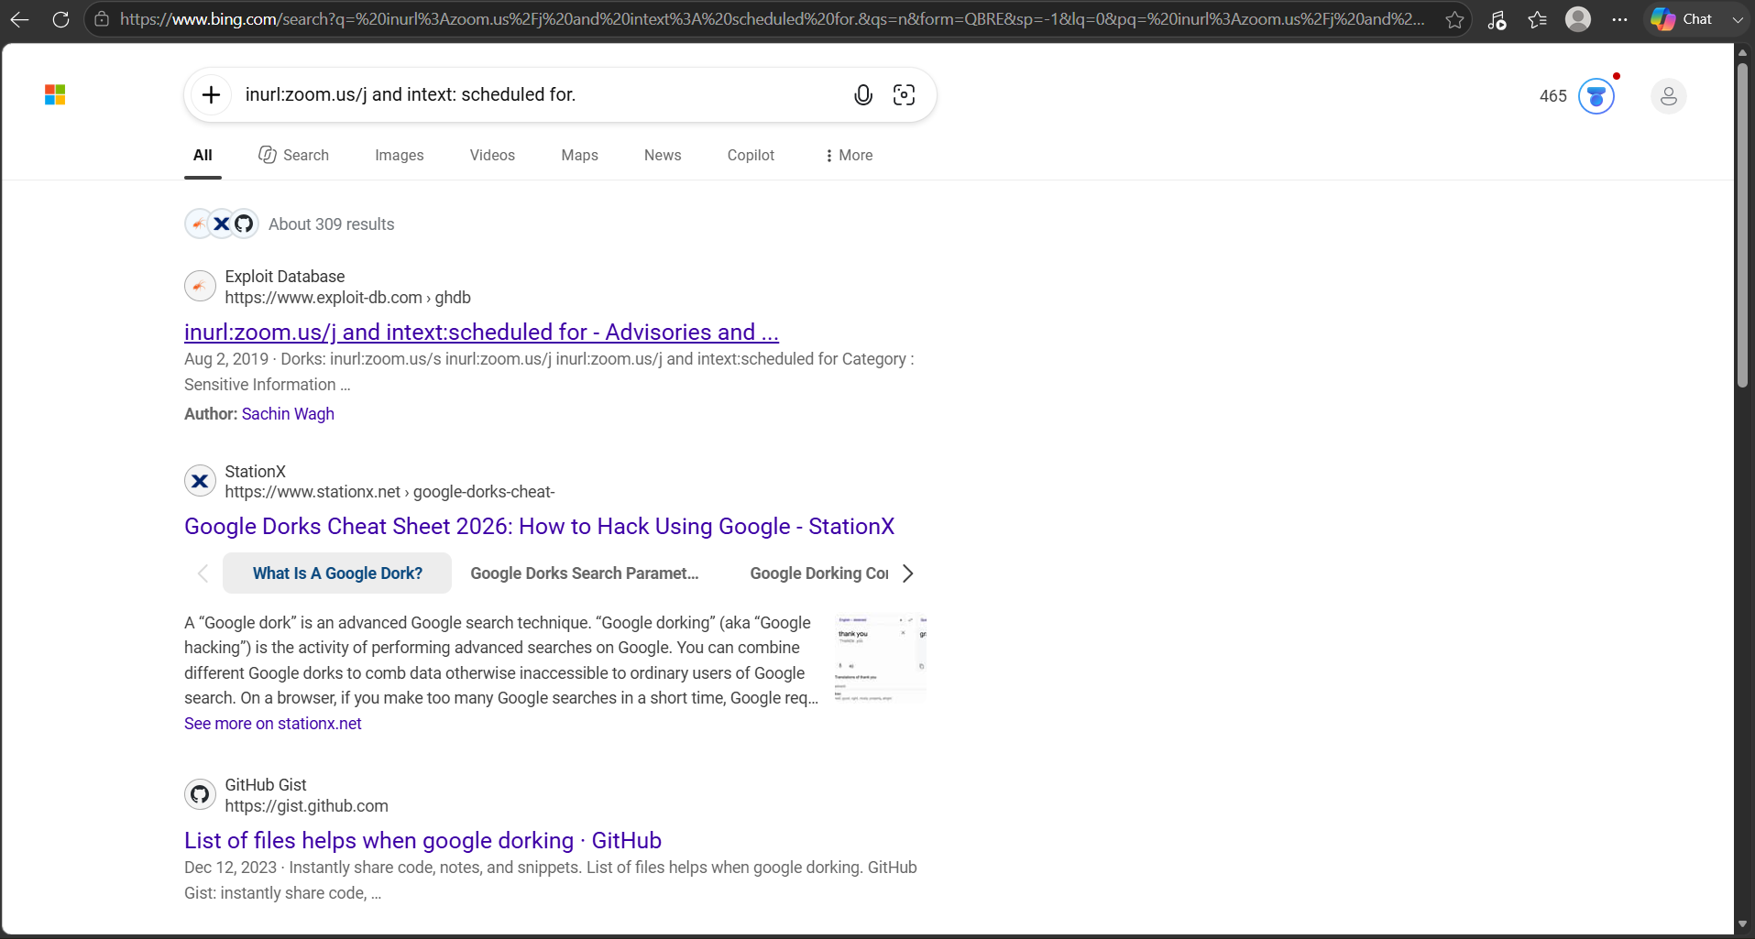
14.SQL Dumps:
Searches for a SQL dumps.
EXAMPLE: "index of""database.sql.zip".
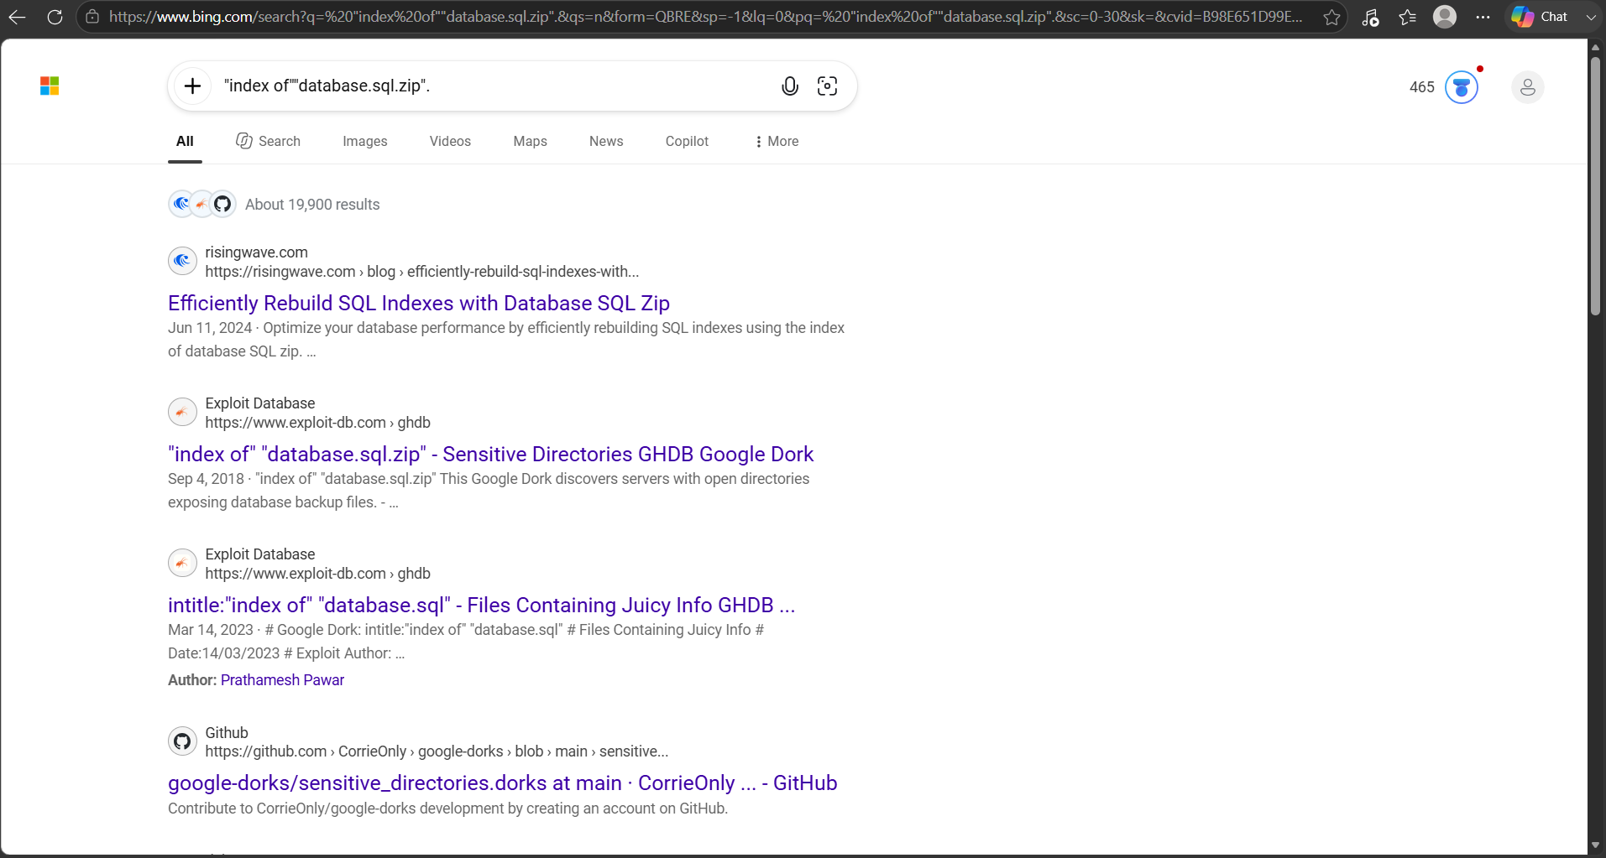
15.Wordpress Admin:
It can searches for a WordPress admin login pages.
EXAMPLE: intitle:"Index of"wp-admin.
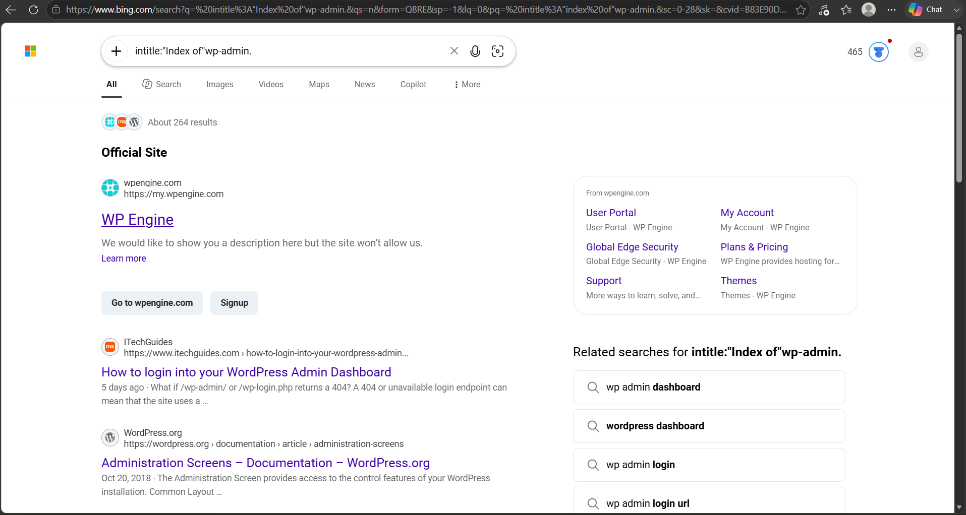
16.Allintitle:
It can searches for a pages with titles containing all the specified keywords.
EXAMPLE: allintitle:cyber security essentials.
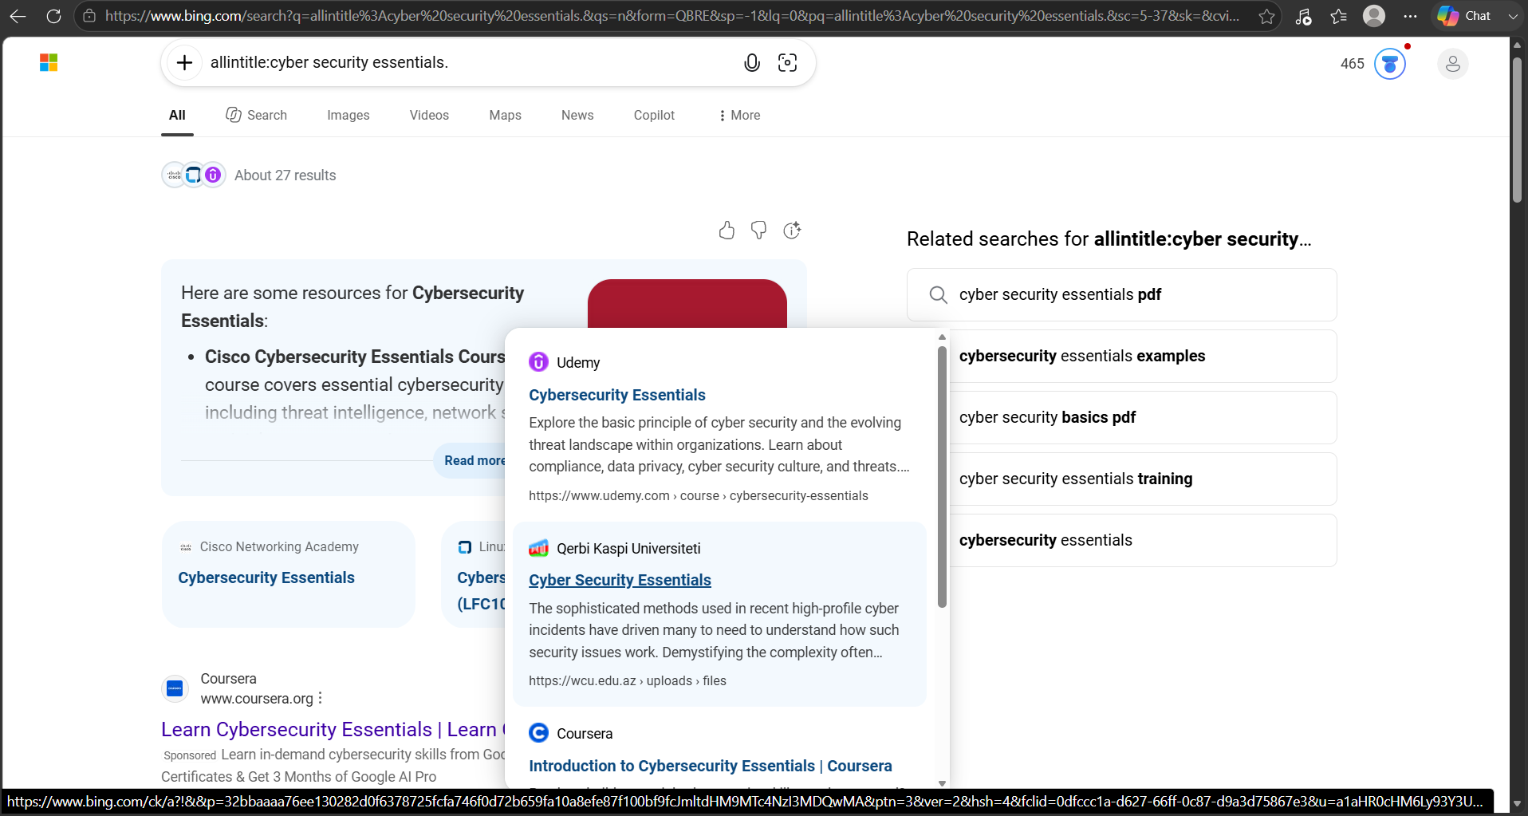
17.Allinurl:
It can searches a URLs containing all the specified keywords.
EXAMPLE: allinurl:cyber security hacker.
